1. b 7000
2. b 62%
3. b dowry prohibition act
4. b reinforce
5. c murder or. … … .
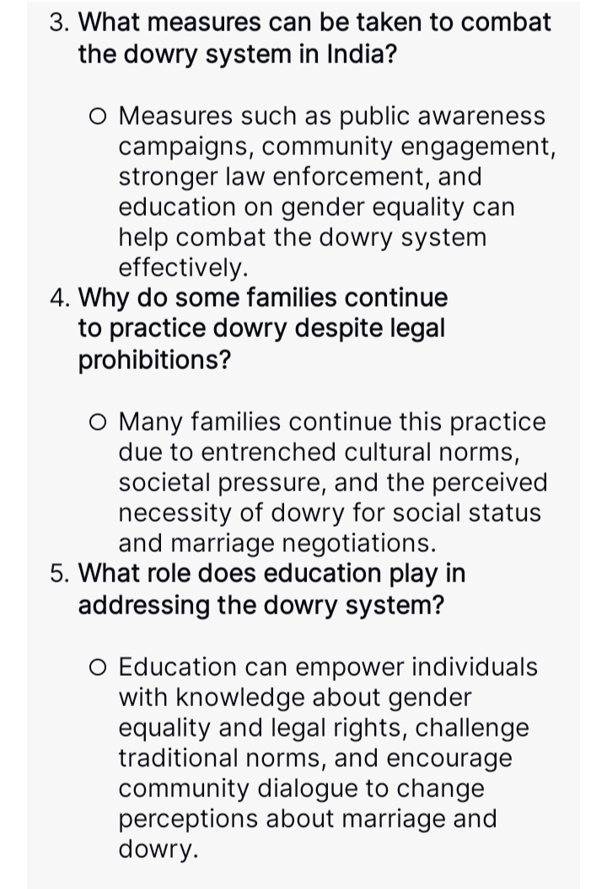
5. C murder or. .....
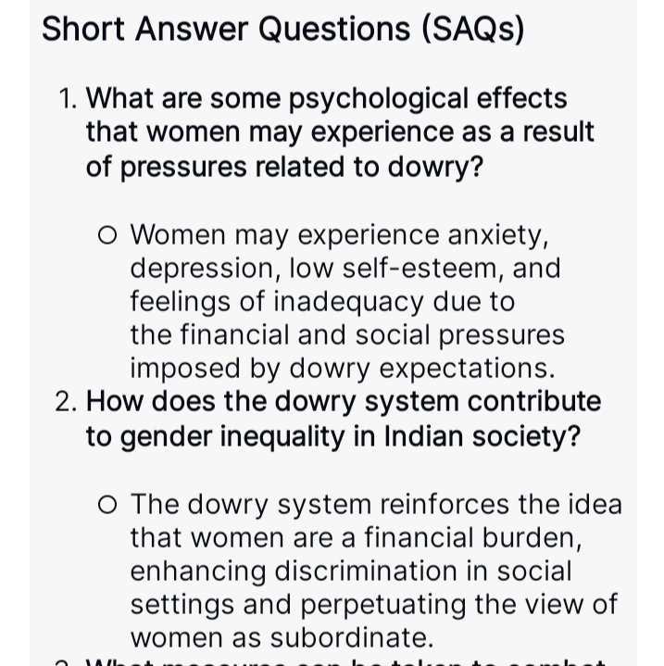

Grammar answer key

Identification of Phrases:

1. Adjective phrase
2. Adverb phrase
3. Adjective phrase
4. Adjective phrase
5. Adjective phrase
6. Adverb phrase
7. Noun phrase
8. Adjective phrase
9. Adjective phrase
10. Noun phrase
11. Adjective phrase
12. Adjective phrase

Identification of Clauses:

1. Adverb clause
2. Noun clause
3. Adjective clause
4. Adverb clause
5. Adjective clause
6. Adverb clause
7. Noun clause
8. Adjective clause
9. Noun clause
10. Noun clause

